******COMSATS University Islamabad (Lahore** **Campus)**

**Assignment <1> FALL 2023**

|  |  |  |  |  |  |  |  |  |
| --- | --- | --- | --- | --- | --- | --- | --- | --- |
| Course Title: | Artificial Intelligence | | | Course Code: | | CSC462 | Credit Hours: | 3(2,1) |
| Course Instructor: | Dr. Atifa Athar | | | Programme Name: | | BS Computer Science | | |
| Semester: | 6th | Batch: | SP21 | Section: | A | Date: | 02-10-2023 | |
| **Due Date:** | **03-10-2023** | | | **Maximum Marks:** | | | **10** | |
| **Student Name:** | **Hassan Mahmood** | | | **Registration No.** | | | **SP20-BCS-114** | |
| **Important Instructions / Guidelines:**   * **No late submissions will be accepted.** * **All assignments are required to be submitted using the attached template only.** | | | | | | | | |

**Question No.1 Marks: 10**

***CLO: <2>; Bloom Taxonomy Level: <Applying>***

Consider the following graph and find the minimum cost of the path starting from S to G using a uniform cost search algorithm.

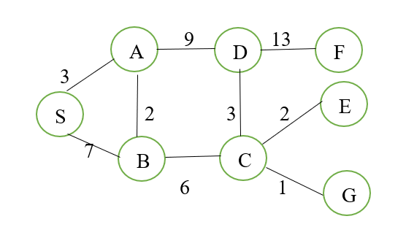

**Tree of the given Path:**

|  |  |  |  |
| --- | --- | --- | --- |
| **PACE** | **Priority Queue** | **Closed** | **Cost** |
| **1-** | (S, 0) | **--** | **0** |
| **2-** | (S,A,3), (S,B,7) | (S,0) | **0** |
| **3-** | (A,B,2), (S,B,7), (A,D,9) | (S,0), (S,A,3) | **3** |
| **4-** | (B,C,6), (S,B,7), (A,D,9) | (S,0), (S,A,3), (A,B,2) | **5** |
| **5-** | (C,G,1), (C,E,2), (C,D,3), (S,B,7), (A,D,9) | (S,0), (S,A,3), (A,B,2), (B,C,6) | **11** |
| **6-** | (C,E,2), (C,D,3), (S,B,7), (A,D,9) | (S,0), (S,A,3), (A,B,2), (B,C,6), (C,G,1) | **12 \*** |
| **7-** | (C,D,3), (S,B,7), (A,D,9) | (S,0), (S,A,3), (A,B,2), (B,C,6), (C,E,2) | **13** |
| **8-** | (S,B,7), (A,D,9), (D,F,13) | (S,0), (S,A,3), (A,B,2), (B,C,6), (C,D,3) | **14** |
| **9-** | (B,A,2), (B,C,6), (A,D,9), (D,F,13) | (S,0), (S,B,7) | **7** |
| **10-** | (B,C,6), (A,D,9), (D,F,13) | (S,0), (S,B,7) ,(B,A,2) | **9** |
| **11-** | (C,G,1), (C,D,3) (A,D,9), (D,F,13) | (S,0), (S,B,7) ,(B,C,6) | **13** |
| **12-** | (C,D,3) (A,D,9), (D,F,13) | (S,0), (S,B,7) ,(B,C,6), (C,G,1), | **14 \*** |
| **13-** | (A,D,9), (D,F,13) | (S,0), (S,B,7) ,(B,C,6), (C,D,3), | **17** |
| **14-** | (D,F,13) | (S,0), (S,A,3), (A,D,9) | **12** |
| **15** | (D,F,13) | (S,0), (S,A,3), (A,D,9), (D,F,13) | **25** |
| **16-** |  | (S,0), (S,B,7) ,(B,C,6), (C,D,3), (D,F,13) | **28** |

**Conclusion:**

After performing all iterations, we got 2 results from A-G which are 12 and 14. So, clearly 12 is the best Cost. Which path is as below

**(S, 0), (S,A,3), (A,B,2), (B,C,6), (C,G,1)**